OFFICIAL COORDINATION REQUEST FOR
NON-ROUTINE OPERATIONS AND MAINTENANCE

COORDINATION TITLE – 15 LWG 025 Lower Granite JBS Primary Outfall Construction
COORDINATION DATE – 15 December 2015, follow-on clarifications 08 February 2016
PROJECT – Lower Granite Lock and Dam
RESPONSE DATE – Initial Response 22 December 2015; Clarifications: 22 February 2016

Description of the problem: The Juvenile Bypass System (JBS) at Lower Granite Dam (LGR) is currently undergoing a variety of upgrades to improve downstream fish passage. As part of this upgrade project, the current primary bypass outfall is being replaced with a new outfall structure that will return downstream migrating fish to a new terminal location in the river. Additional time during the fall of 2016 is necessary to complete all in-water work activities associated with the installation of this new primary bypass outfall structure and subsequent removal of the existing outfall structures. To complete this bypass outfall work, the Corps proposes to conduct in-water construction activities in the LGR tailrace 15 November 2016 to 28 February 2017.

Type of outage required: The in-water work window will be extended to occur from 15 November 2016 to 28 February 2017 to support bypass outfall construction activities. No additional LGR facility outages will be required to support these construction activities beyond those previously coordinated through FPOM and NWW FFRDWG (e.g. 13 LWG 17).

Impact on facility operation: Construction activities will occur in the LGR tailrace Boat Restricted Zone (BRZ) by a Corps contractor. Therefore, the contractor’s activities will be closely coordinated with LGR to ensure constructions activities are conducted safely in the BRZ.

The LGR JBS will be shut down 1 August 2016 to 24 March 2017, as previously coordinated with FPOM and FFDRWG, to support concrete mining of the collection channel and cross-over activities associated with tie-in of new project features to the JBS (13 LWG 17 Juvenile Fish Collection Channel Upgrade; 15 LWG 004 LWG JFF Construction). Per MOC “13 LWG 17 Juvenile Fish Collection Channel Upgrade”, the Corps will operate the RSW 12 hours per day (6 am to 6pm) from 1 September to 15 December (i.e. Daytime Hours) if there is sufficient water to operate the RSW and maintain minimum generation requirements during low flow conditions as defined in the FOP. Changes to this RSW operation, from 15 November to 15 December 2016, may be necessary to facilitate safe construction of the new primary bypass outfall in the LGR tailrace during this in-water work window in order to complete construction activities prior to the 2017 fish passage season.

If modifications the spill levels coordinated in FPOM MOC 13 LWG 17 are necessary to facilitate outfall construction efforts, the Corps will prioritize spill related actions in the following order during the 15 November to 15 December 2016 time period:
- Continue daytime (6 am to 6 pm) RSW operations as proposed in FPOM MOC 13 LWG 17. As a note, more than 6.8 kcfs may be discharged through the RSW during periods when Lower Granite Dam is operated at higher project heads.
- Pass approximately 6.8 kcfs (4 stops) through 2 bays in a manner that facilitates safe tailrace conditions for construction activities while providing larger spillbay openings for adult salmonids that may be passing through this spill route. This modified bulk pattern will be implemented initially in bays 6 and 8 at two stops each, and, if necessary, subsequently adaptively managed in coordination with RCC and Lower Granite Dam operators to facilitate suitable tailrace conditions.
- Pass approximately 6.8 kcfs (4 stops) through a non-RSW spill pattern in accordance with the 2016 FPP Table LWG-9, as modified per approved Change Form “16LWG005 - Low Flow Spill Patterns w/ No RSW”
- Pass a reduced amount of water (1-3 stops; 1.7 – 5.1 kcfs) that allows for safe in-water work conditions through a non-RSW spill pattern in accordance with the 2016 FPP Table LWG-9, as modified per approved Change Form “16LWG005 - Low Flow Spill Patterns w/ No RSW”
- Terminate spill during periods when spill operations described herein and in MOC 13 LWG 17 conflict with in-water construction activities

Turbine units will be operated in order of priority defined in the 2016 FPP Table LWG-5 to the extent possible during this construction period (15 November to 28 February). If a unit is out of service, the next available unit in the priority order will be operated. If necessary to deviate from FPP unit priority order while installing orifices in units 2 and 3 (see 13 LWG 17), the Corps will further coordinate with FPOM and keep the adjacent unit available for service (e.g., unit 3 will be available while unit 2 is offline).

Table LWG-5. Lower Granite Dam Turbine Unit Operating Priority Order.
Season | Duration | Unit Priority
March 1 – December 15 Fish Passage Season | Start Units | 2, 3, then 4-6 any order, then 1 a
March 1 – December 15 Fish Passage Season | Stop Units b | 4-6 any order, then 3, 2, 1 b
December 16 – end of February Winter Maintenance Period | Stop/Start Units | Any Order
- Unit 1 has fixed Kaplan blades (non-adjustable) and can only operate in the upper 1% range. The priority order minimizes Unit 1 starts/stops and allows for the longest runtime once Unit 1 is started.
b. Stop units in reverse Start order, except run Unit 1 as long as BPA load request and required spill rate can be met.

Dates of impacts/repairs: The in-water work window will be extended by one month to occur from 15 November 2015 to 28 February 2017 to facilitate primary bypass outfall construction.

Length of time for repairs: It is anticipated that the in-water construction activities will occur from 15 November 2016 through February 2017. The new JBS features, including the new primary bypass outfall, will be commissioned in February-March 2017 to ensure the LGR JBS is operational prior to the 2017 fish passage season.

Expected impacts on fish passage: In-water work will primarily be conducted from a floating barge platform and limited distances from shore. As such, fish will be able to pass through the tailrace largely unobstructed during in-water work starting 15 November 2016. There are a limited numbers of juvenile salmonids passing through the project downstream during the 15 November to 15 December timeframe with the JBS typically operated during this time period for bypassing adult salmon fallbacks (Fish Passage Plan Chapter 9 – Lower Granite Dam – 2.3.1 Juvenile Fish Passage Facilities; and Table LWG-1).

Typically less than 30 adult chinook per day pass Lower Granite Dam starting 15 November. Up to 500 adult steelhead per day may be passing the project upstream during this time period (Figure 2).

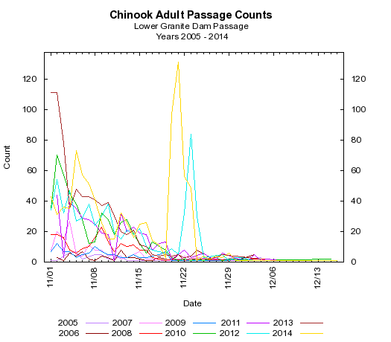

Figure 1. Adult Chinook passage counts for 2005-2014.

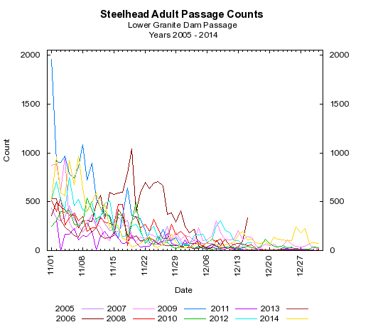
Figure 2. Adult steelhead passage counts for 2005-2014.

Table 1. – Adult salmonid fallback at Lower Granite Dam, 2006 to 2012. Data collected by USACE personnel as adult salmonids cross the JFF separator.

Year | August | September | October
2006 | 51 | 335 | 630
2007 | 67 | 270 | 846
2008 | 275 | 798 | 2,253
2009 | 247 | 3,462 | 2,940
2010 | 477 | 1,202 | 1,919
2011 | 179 | 1,547 | 2,787
2012 | 81 | 752 | 2,090

A known fall Chinook spawning area will be disturbed as part of constructing the new primary bypass outfall structure during this time period. It is possible that 5-10 fall chinook redds may be disturbed based on historical survey efforts (Figure 3). The shutdown of the JBS in August will reduce the likelihood of fall Chinook spawning in the area due to no water discharge from the JBS during the spawning period. As discussed at the 28 May 2015 NWW FFDRWG meeting, no new spawning surveys will be conducted as part of constructing the new primary bypass outfall.

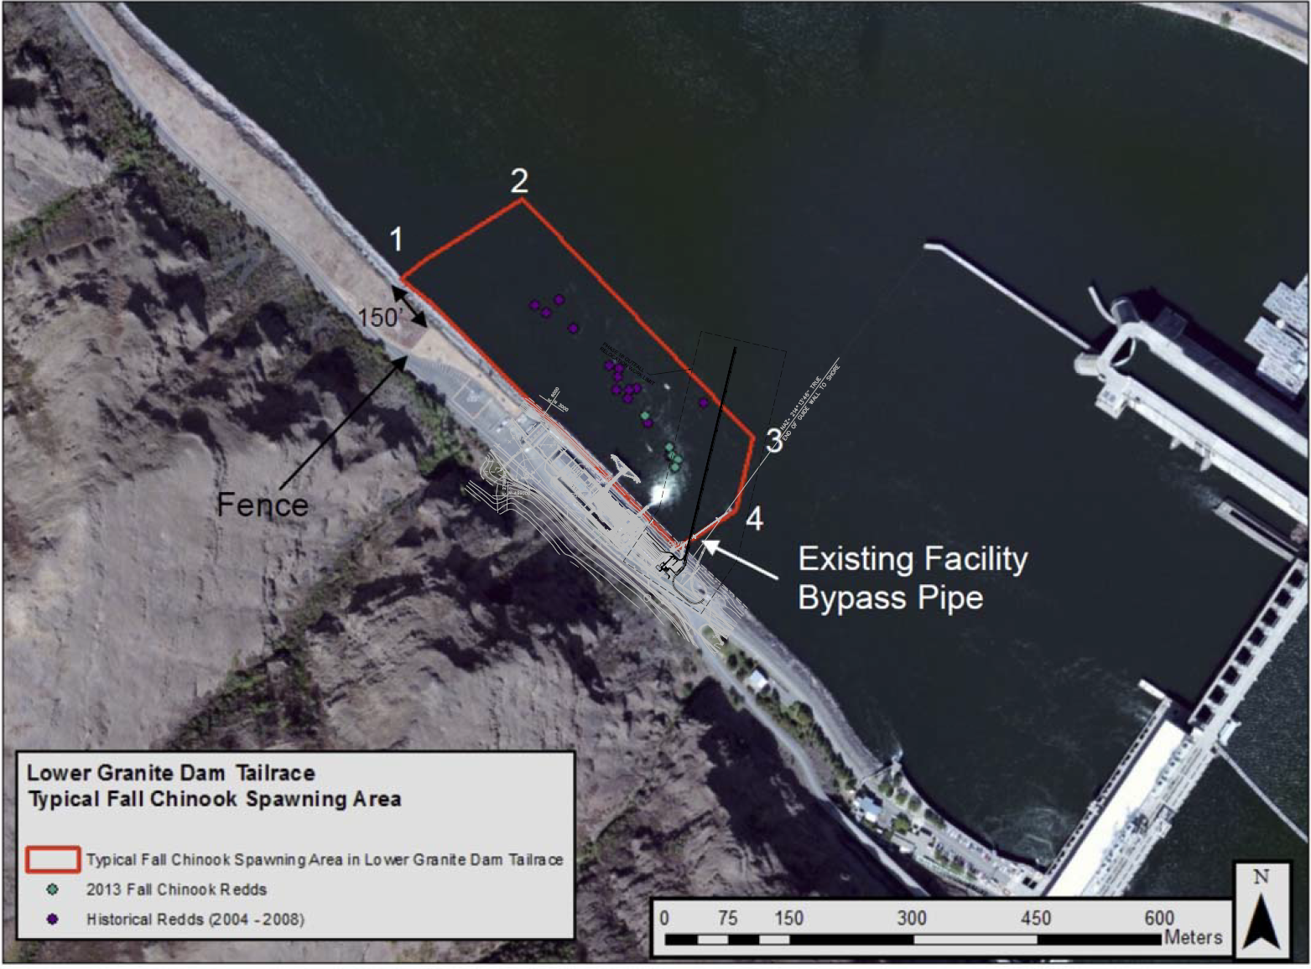
Figure 3. Typical fall Chinook spawning area in the Lower Granite Dam tailrace and new outfall construction area.

Comments from agencies

The proposed in-water work window of 15-November to 29 February was discussed at the NWW FFDRWG meeting 7 December 2015. NOAA and CRITFC indicated they were ok with the extended in-water work window for this primary bypass outfall construction project and that fall 2016 RSW operations could be modified or eliminated if necessary to facilitate successful completion of outfall construction activities. No other FFDRWG members provided feedback at the 7 December 2016 FFDRWG meeting.

The potential to disturb fall Chinook redds during in-water construction activities was discussed at NWW FFDRWG at the 28 May 2015 meeting. All participating fish managers including NOAA agreed to proceed with bypass outfall construction activities during the 2016/17 in-water work window without conducting additional spawning surveys or modifications to the new primary bypass outfall footprint.

December 2015 FPOM Notes:

3.1.1.1.1. The one month earlier shutdown for the primary outfall at LWG is still planned for November, the MOC is out for comment and they would like to get it into the plans and specs now. Flat spill would need to be discussed to occur during the work. Conder was concerned about juvenile passage. Setter said there weren’t very many during that time of year and that a turbine operation that late in the season wasn’t an issue. Trumbo asked if unit operations could be changed if the contractor had issues with the hydraulics. Trachtenbarg will check to see if flat spill is an option, if a barge would be allowed in the tailrace if spill is occurring. The project needs to be contacted to see what the contractor will allow. ACTION: NWW will have an internal discussion and report back to FPOM.

Final results

David Trachtenbarg
Fish Biologist
Environmental Analysis Section
U.S. Army Corps of Engineers
Walla Walla District
201 N 3rd Ave.
Walla Walla, WA 99362
Phone: 509-527-7238

